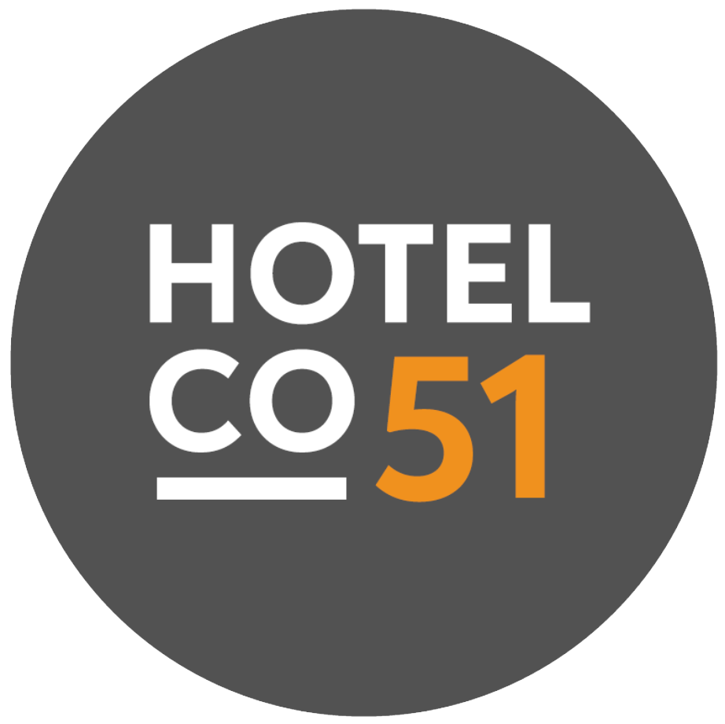
PRIVACY CHAMPION GUIDANCE
Privacy Guidelines for Hotel Captains
- You are the local first point of contact for privacy questions and the eyes and ears of the Privacy Officer at your hotel.
Responsibilities  • Act as first point of contact for privacy questions within the entity.  • Identify new or changed local processing activities and inform the Privacy Officer and Data Protection Officer.  • Maintain local data mapping inputs and Record of Processing Activities for the entity.  • Support DPIAs with the Privacy Officer and provide local inputs where needed. | What to watch for  • Data breaches: loss, theft, hacking, wrong recipient, unauthorised access, alteration, or loss of availability of personal data.  • Data subject requests: access, rectification, erasure, restriction, portability, objection, or consent withdrawal.  • CCTV: signage missing, private areas in scope, audio recording, or other use outside the stated purpose. Check CCTV Policy.  • New data collection or monitoring: new forms, tools, check-in steps, kiosks, Wi-Fi flows, or local tracking.
Escalate immediately  • Suspected or actual personal data breach: report immediately to your line manager and the DPO. Action must start without undue delay, and authority notification may be required within 72 hours.  • Written data subject request received locally: forward to the DPO straight away. Requests are handled in writing and the response target is 30 calendar days once the required information is received.  • High-risk or unusual processing: involve the Privacy Officer before launch or change, especially for monitoring, CCTV, employee data, or guest profiling.  • Any material privacy risk, repeated issue, or likely policy deviation. | Daily habits  • Keep a clean desk and clean screen: do not leave registration cards, passports, invoices, or staff records unattended.  • Lock screens when stepping away and store paper records securely.  • Share personal data only with authorized people and only through approved channels.  • For CCTV access requests, requests must follow the formal data subject request process; other people visible in footage must be protected.  • Use dpo@hotelco51.com for privacy questions, escalation, and support.
Contacts  DPO: dpo@hotelco51.com  Privacy Officer: lucas.noronha@hotelco51.com | 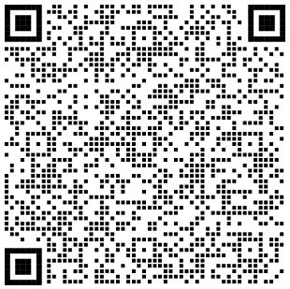  CHECK THE POLICIES:

